**EXPERIMENT-5: Title: Graph Algorithms**

1. Find Minimum Cost Spanning Tree of a given undirected graph using Kruskal’s algorithm

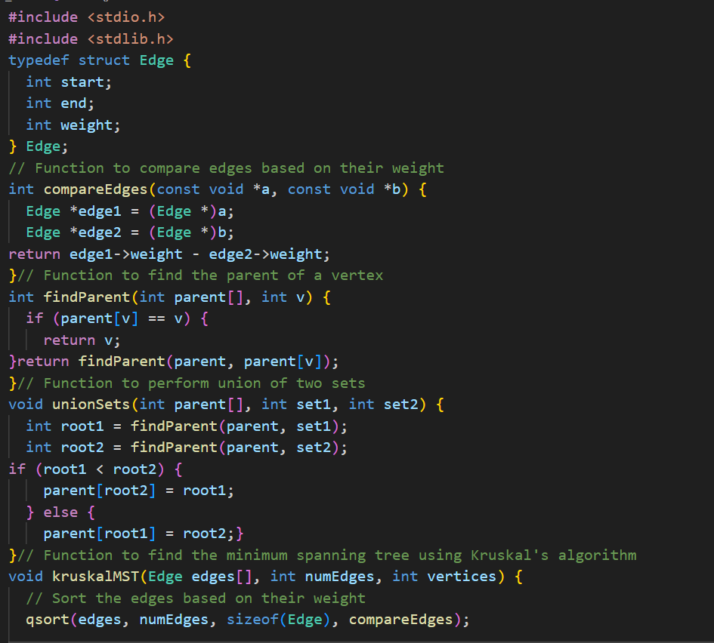

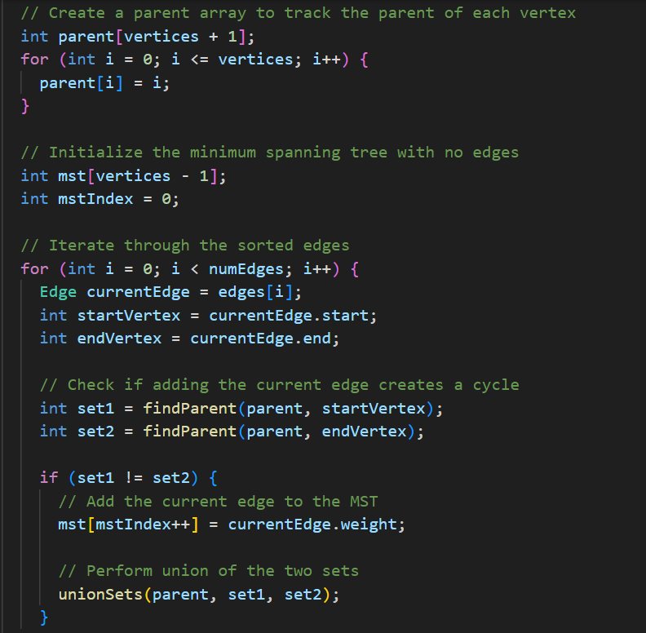

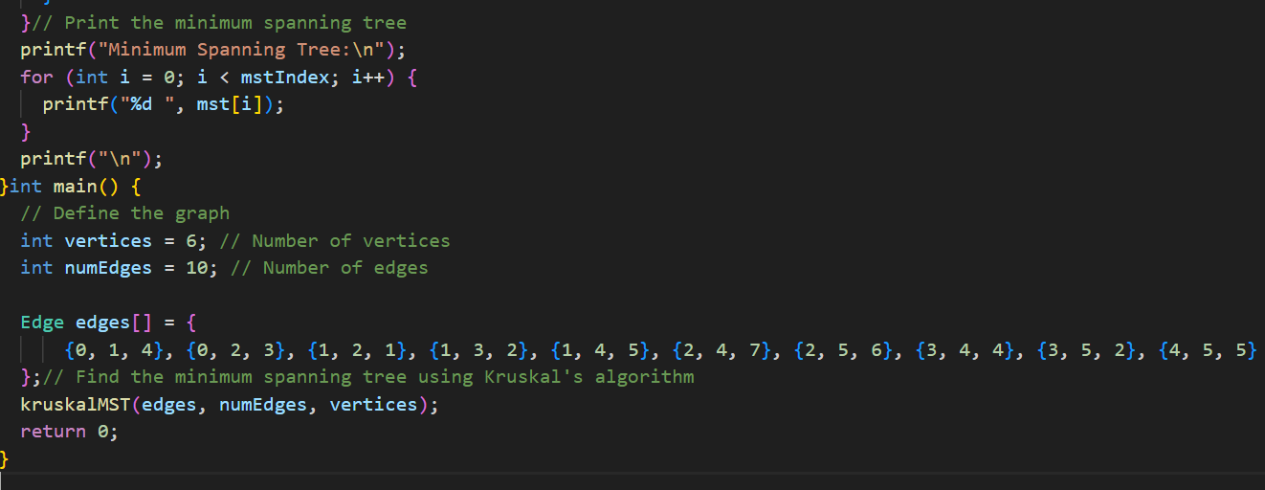

2. Find Minimum Cost Spanning Tree of a given undirected graph using prim's algorithm.

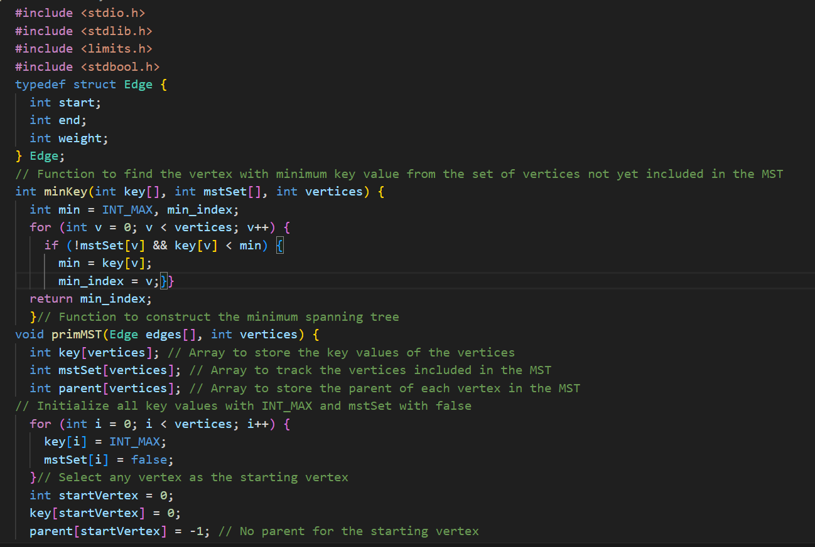

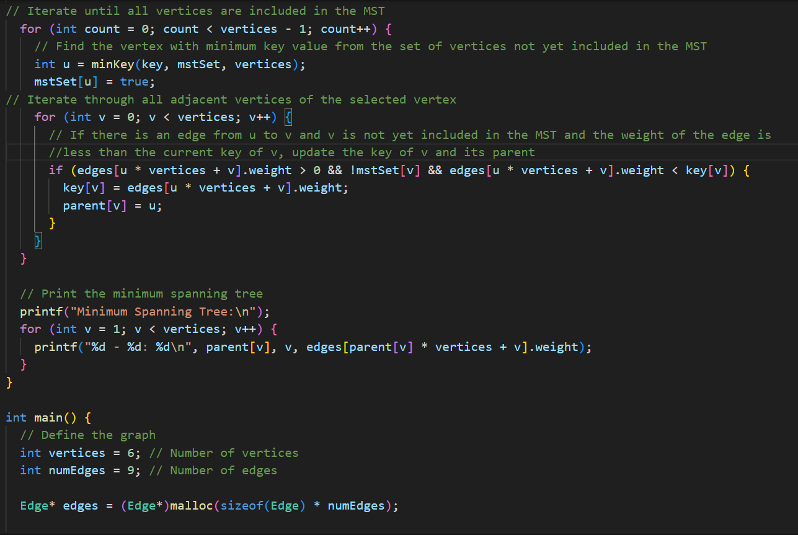

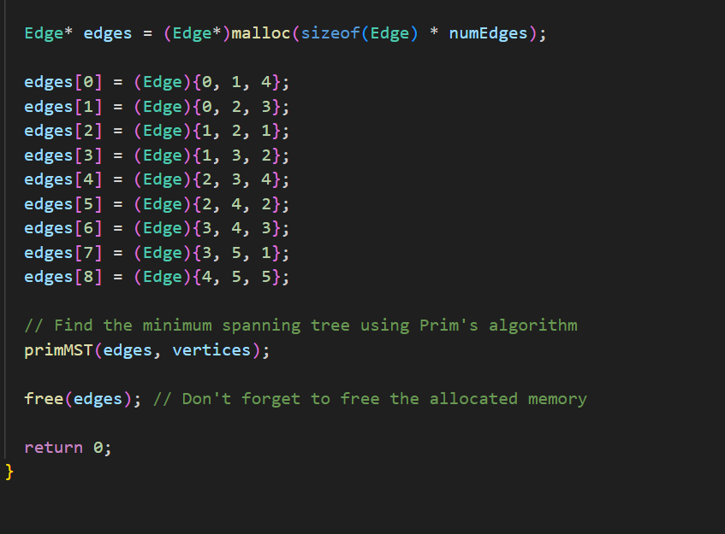

Output:-

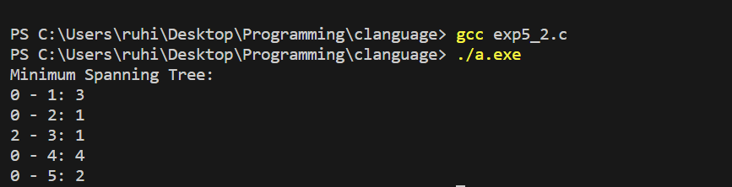

3.From a given vertex in a weighted connected graph, find shortest paths to other vertices using Dijkstra's algorithm

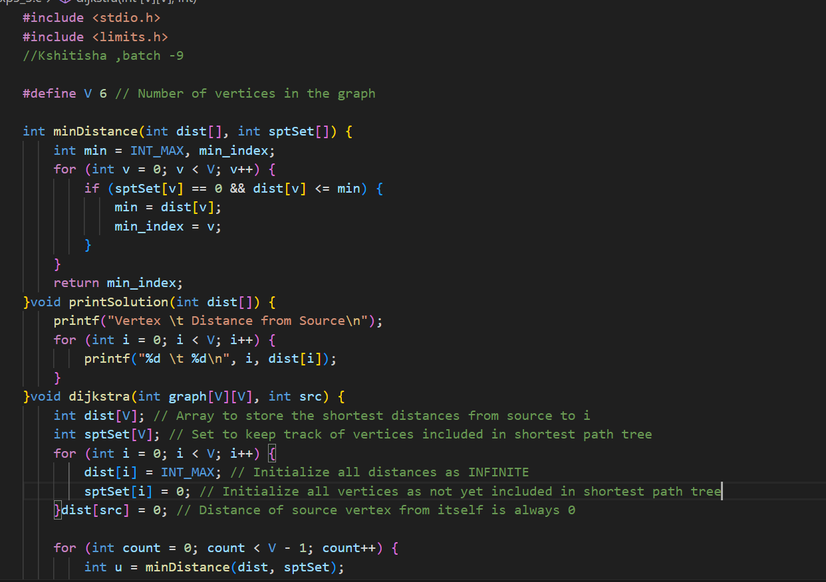

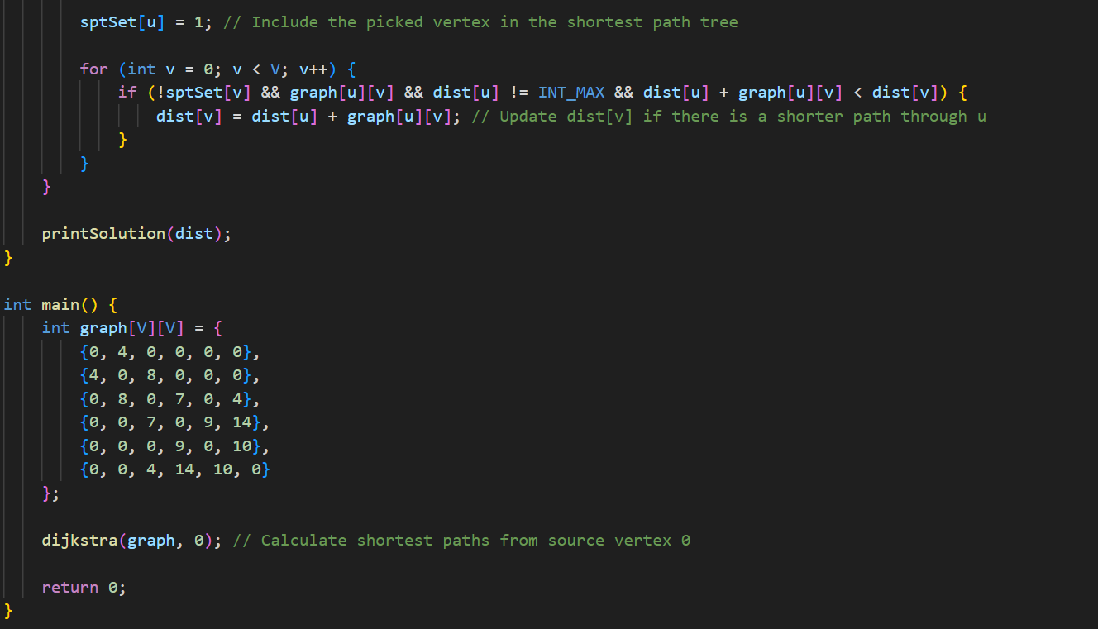

Output:

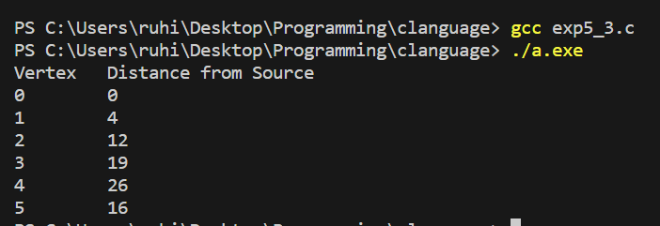

4. From a given vertex in a weighted connected graph, find shortest paths to other vertices negative weights (using Bellman-Ford algorithm).

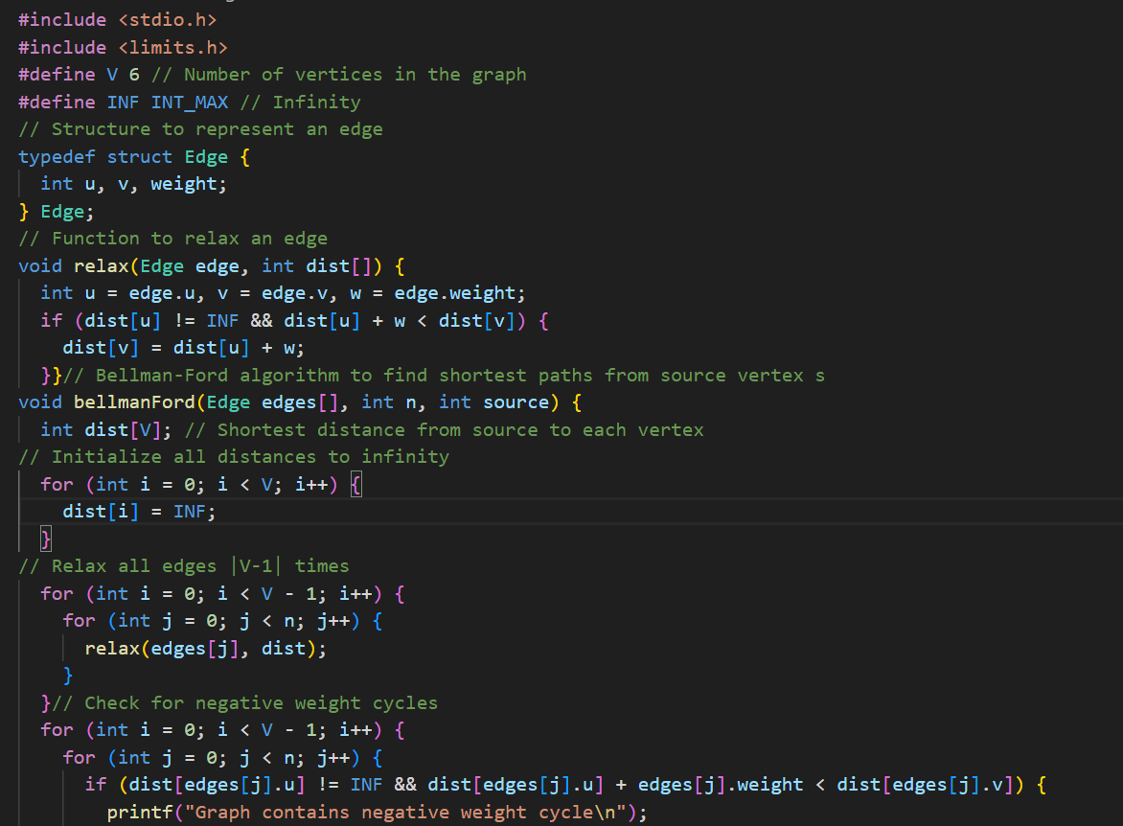

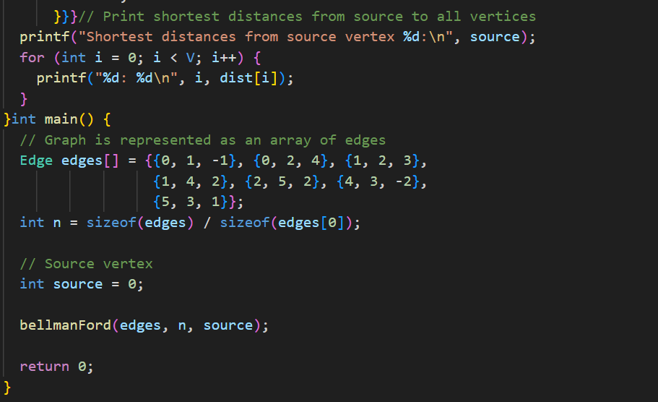

Output:

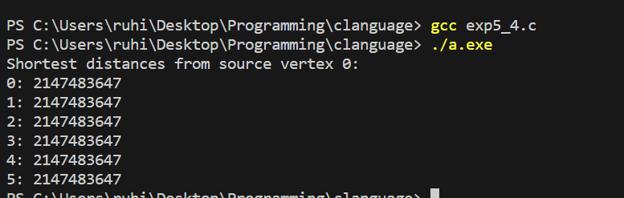

5. Print all the nodes reachable from a given starting node in a digraph using BFS method. Check whether a given graph is connected or not using DFS method.

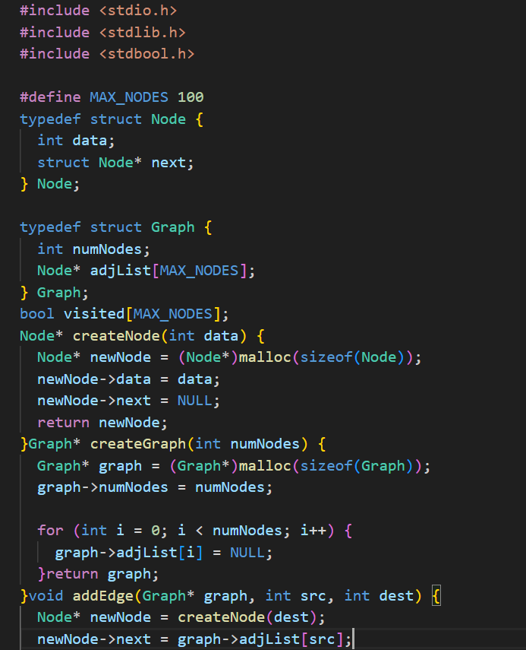

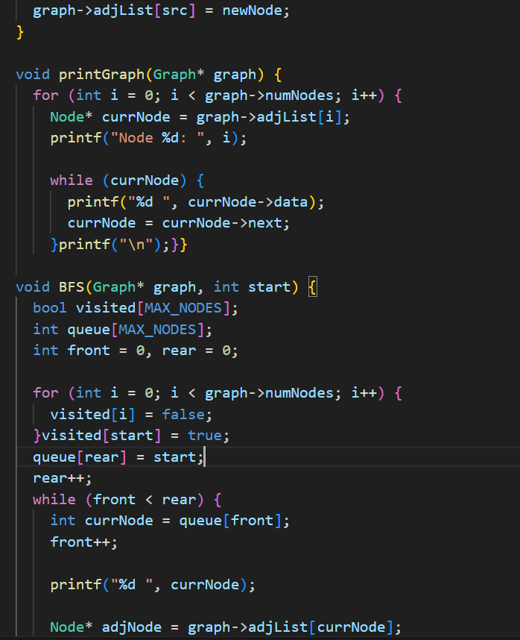

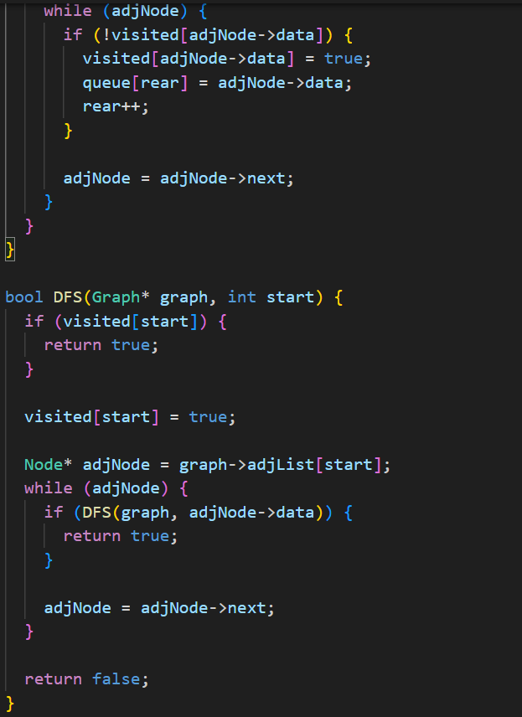

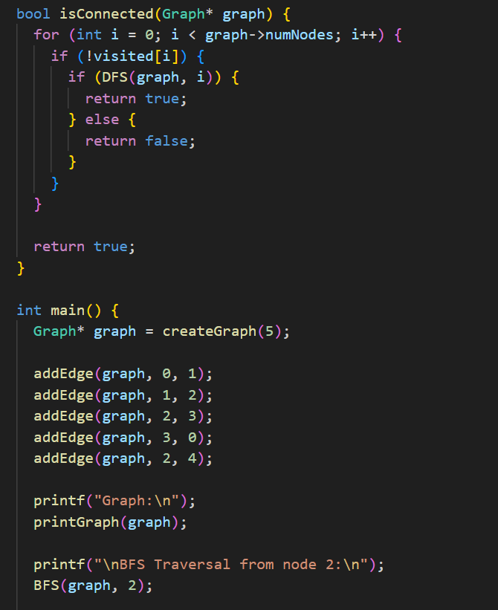

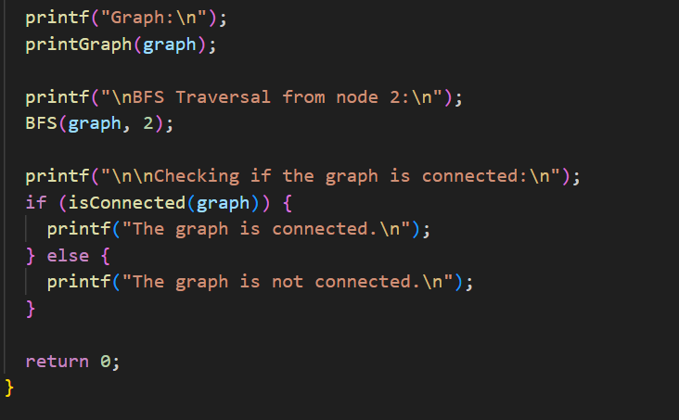

Output

